 | Abdi İpekçi Caddesi Kaşıkçıoğlu Apt. No:42 D:2 34365 Nişantaşı İstanbul  www.artxist.com  info@artxist.com  T. +90 212 291 77 84 F. +90 212 343 69 35 | PRESS RELEASE

DECOLIFE

The first exhibition of an international artist at x-ist "Mind the Gap" by the Brasilian street artist DECOLIFE
(or Deco) will take place between 30 November - 21 December, 2013.

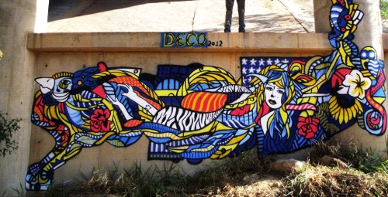

Andre' Ruiz de Freitas, also known as DECOLIFE, is a street artist working and living in London.
He studied electronics for two years in Sao Paulo, where he was born, before he traveled to different cities of the world to draw graffiti and meet other street artists.
In 2010, the artist had his first exhibition at the Amart Gallery in Tatui-Sao Paulo where he acquired the street name DECOLIFE. In 2011, the Deco worked with "Mapa Cultural Paulista" (Paulista Cultural Map) and had exhibitions in different cities of Brasil. He also took place in Contemporary Istanbul 2013.
DECOLIFE, whose works are in different cities all around the world, will present his graffiti work on the walls of x-ist in his first show in Istanbul.

DECOLIFE, “Mind the Gap”, 2013
Catalogue Text

“It feels like God gives me direction in my work and I’m only following the signs. These signs appear in my dreams. In all my work, you only see dreams and love.”

Andre, who’s born in 1990, is known under the street name DECOLIFE by his followers, or in short Deco.

I met Deco in London, where I live, through my expertise which is street art. When I mentioned I was charmed by his first piece he made in London, he told me that he was drawing since a very young age.

“It’s very clear” I said. Only a great innate talent could explain this kind of professionally executed work made at such a young age.

As I got to know him and we became close friends, I realized that he lives for art and that his spiritual connection to life and all beings also makes him a great thinker.

I witnessed his strong stand against alcohol and drugs in Sao Paulo, where he was born, and that made him an example for all the youth there. He quickly distinguished himself amongst his peers who were also raised in Sao Paulo.

I recommend those who doubt that street art is the most important art movement in the recent years to take a look at the great works made on the streets of London, New York, Sao Paulo or any other big city. Street art made freely, without any censorship making use of all different kinds of techniques transforms cities into open air galleries or giant canvases. To fully comprehend the level to which street art and artists have reached, one can simply examine the Sotheby’s or Christie’s records or the collections of well-known museums and galleries such as MOMA, Victoria and Albert Museum and Tate Gallery. This expressionist movement that was regarded as vandalism in the 1960s has been legalized today. The competition between hundreds of street artists grew as graffiti and street art were separately defined in the 1980s. Especially after the artists such as Banksy, Shepard Fairey and Swoon whose works reached hundreds of thousands of dollars worth of value...

Deco has made a presence in this competition as well and he’s already ahead of his peers. His technique is studied and acclaimed by the experts; international press is closely following his work, and the number of fans on his blog is increasing every day. I have no doubt that a very successful career is awaiting him.

Today Urban Art, as we call it, is an art movement that’s closely followed by many international galleries, curators and collectors. I congratulate x-ist for pioneering in showing this movement in Turkey where it’s just newly recognized. I’m positive that it will greatly contribute to the presentation and the promotion of street art in general.

“I’ve been drawing since I was a little kid. I wanted the people who’re rushing from one place to another in Sao Paulo to stop for a moment and discover their reflections in my works on the walls of the city. What is essential to me in life is that everything I do and draw makes me happy.”

Eser Nisan Yağmur
MFA Urban Art Critic and Expert
Member of RSA_Graffiti, Royal Photographic Society, London Photographic Society, AFSAD

